EVENT PROCESSING IN PRACTICE

This part of the website provides connection between the main concepts discussed in the book and various implementations in practice, this is a vertical view of these topics, for horizontal, language oriented, view refer to the implementation by language page.

Event types

Event types are typically defined by some kind of schema.
In many of the current languages event schema is defined in a similar way to database relations. This can be represented as a tree structure like in Apama:

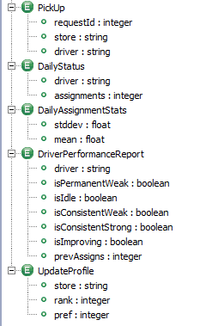
In this example we see a rule structure of some of the event types in the FFD example. This shows the event type name and payload for each event. For more information refer to the Apama FFD example.

Another example similar to database relation is CCL.

CREATE SCHEMA AssignmentSchema (
RequestID INTEGER,
Store STRING,
Driver STRING,
DeliveryLatitude FLOAT,
DeliveryLongitude FLOAT,
RequiredPickUpTime TIMESTAMP,
RequiredDeliveryTime TIMESTAMP
);

CREATE OUTPUT STREAM Assignment SCHEMA AssignmentSchema;
CREATE INPUT STREAM ManualAssignment_s SCHEMA AssignmentSchema;

This is an event type definition in CCL. The event payload is being defined as SQL schema, where there are two streams: INPUT STREAM for manual assignments which represent raw events, and OUTPUT STREAM for automatic assignments represent derived events, both of them mapped to the same schema. For more details refer to the CCL FFD example.

Rulecore provides event types definitions as XML document, as noted below:

<EventDef eventType="DeliveryRequest">
<Description>Event: DeliveryRequest</Description>
<Properties>
<Property name="RequestId">
<base:XPath>string(base:EventBody/user:RequestId)</base:XPath>
</Property>
<Property name="Store">
<base:XPath>string(base:EventBody/user:Store)</base:XPath>
</Property>
<Property name="Driver">
<base:XPath>string(base:EventBody/user:Driver)</base:XPath>
</Property>
<Property name="AddresseeLocation"> <base:XPath>string(base:EventBody/user:AddresseeLocation)</base:XPath>
</Property>
<Property name="RequiredPickupTime"> <base:XPath>string(base:EventBody/user:RequiredPickupTime)</base:XPath>
</Property>
<Property name="RequiredDeliveryTime"> <base:XPath>string(base:EventBody/user:RequiredDeliveryTime)
</base:XPath>
<Property name="MinimumRanking"> <base:XPath>string(base:EventBody/user:MinimumRanking)
</base:XPath>

</Property>
</Properties>
</EventDef>

In ruleCore an event instance is modeled as an XML document, and has a fixed set of header attributes common to all event types. The payload part of the event type is defined using a sequence of XML elements (the Property elements). Each Property element gives the name of the attribute, and an XPath expression that shows where the attribute can be found in the event document. This means that the event instance can have a complex structure, but the attributes can be given simple names. For more information refer to the ruleCore FFD example.

Event Processing Networks

Some systems provide explicit view of the event flow as part of their model, and enable to design the system through the event flow. An example of such an approach is the Streambase Event Flow user interface shown below:

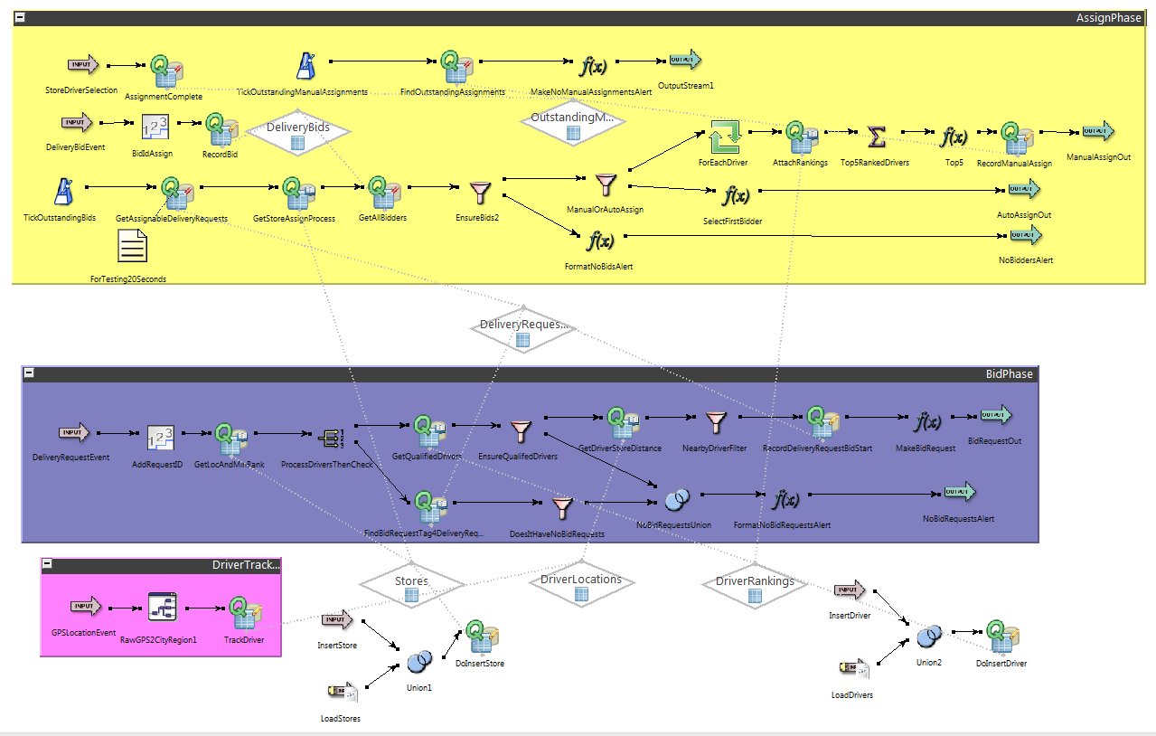
This shows part of the FFD example as an event flow. The flow is composed of a directed graph, where the nodes in the graphs are various icons, each of them designates different type of operation, the edges designate events flowing among the nodes, while dotted edges, designate reading or writing to global stores. For more details refer to the Streambase FFD example.

Filters and transformations

Filters and transformations are expressed in various ways in languages.

This example in Esper implements the BidRequest creation

insert into BidRequest(requestId, store, location, pickupTime, deliveryTime,
storeManual)
select d.requestId, d.store, d.location, d.pickupTime, d.deliveryTime, s.manual
from
DeliveryRequest d unidirectional,
GPSLocationW g
//,sql:DomainDB['select ranking from Driver where driver = ${g.driver} and ranking
> ${d.minimumRanking}']
,method:Domain.driverRankLookup(g.driver) r
,method:Domain.isStoreManualLookup(d.store) s
where Geo.distanceKM(g.location, d.location) < 10
and r.ranking >= d.minimumRanking;

In this example the derived event is created using the SQL command insert into.
The enrichment done using two methods; the first one performs lookup for drivers that satisfy the ranking requirements and the second one performs lookup for stores to find whether it prefers manual or automatic assignment. In addition there is location check for the drivers. As seen this is a combination of SQL with call to Java methods. For more details see the Esper FFD example.

Another example is in Apama, which shows transformation example using imperative language

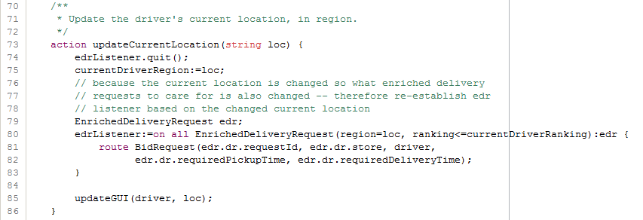
This is a transformation that enriches the Delivery Request with the current location of a driver, For more details see the Apama FFD example.

The next example is a filtering example in Streambase Event Flow UI:

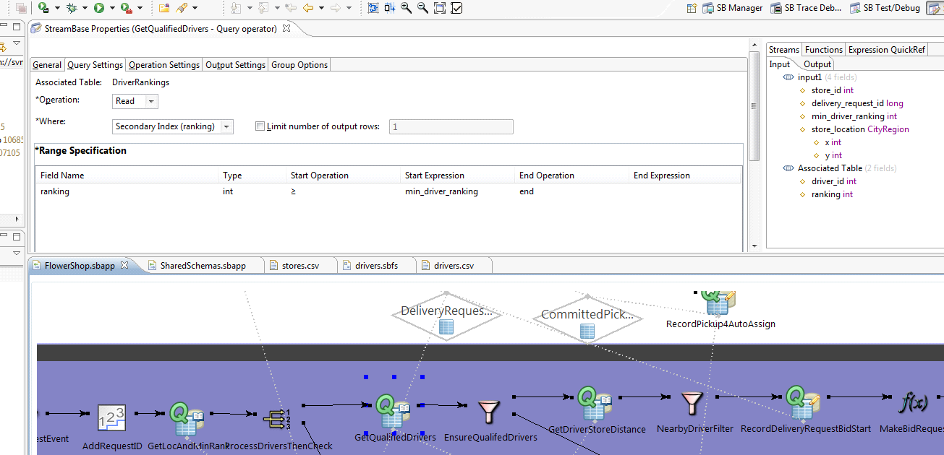
This example is a filter which filter- in drivers that satisfy the store's minimal ranking. This is done as "Range Specification" for the attribute ranking.
Event processing patterns

Event processing patterns are being represented in various ways by the various programming styles.

A logic programming view can be seen within the Etalis implementation:

%A delivery_alert is reported if a delivery_confirmation has not been reported
% within ten minutes of the commited delivery time.
% check_delivery/4
exceptionAlarmAbsoluteDatime(check_delivery(DeliveryRequestId,StoreId,DriverId,
DeliveryTime),CheckTimeDelivery)<-
assignment(DeliveryRequestId,StoreId,ToCoordinates,DeliveryTime,
DriverId,_ScheduledPickupTime) where
(check_delivery_time(WaitDuration),
addSec_Datime(WaitDuration,DeliveryTime,CheckTimeDelivery)).
print_trigger(check_delivery/4).

This Etalis example shows Delivery Alert, which is an absence pattern, designating time out. Note that this is achieved through logic programming inference. For more details see the ETALIS FFD example.

Another pattern example is the Automatic Assignment in CCL with implements the any patterns, selecting the first bidder which meets the eligibility criteria:

/ Automatic takes the first bid "among the selected drivers".
// "Two minutes after the broadcast ..." in the spec implies that we wait for
// the two minutes, rather than picking off the first bid as it appears.

CREATE STREAM AutoDeliveryBid ;

INSERT INTO AutoDeliveryBid
SELECT CB.*,
DS.RequestID AS DSRequestID,
DS.DeliveryLatitude AS DeliveryLatitude,
DS.DeliveryLongitude AS DeliveryLongitude,
DS.RequiredPickUpTime AS RequiredPickUpTime,
DS.RequiredDeliveryTime AS RequiredDeliveryTime,
DS.Store AS DSStore
FROM DeliverySelection AS DS LEFT OUTER JOIN CurrentBids AS CB
ON DS.RequestID = CB.RequestID
WHERE DS.Automatic
ORDER BY Ts PER CB.RequestID
LIMIT 1 ROWS PER CB.RequestID;

This pattern is implemented as SQL query, creating the derived event as a stream, copying attributes from the input streams of DeliverySelection and CurrentBids, and taking the first bidder by ordering the bids and then limit the rows to one. For more details see the CCL FFD example.

